2. Your polished viva answer
You can use this version during your GUVI viva.
My project is a Multi-Agent Customer Support Intelligence Platform designed to automate the initial handling of e-commerce customer support tickets.
When a customer submits a ticket, the system processes the input and passes it to the Classification Agent. This agent predicts the ticket category, priority, and sentiment using trained machine-learning models.
Next, the Retrieval Agent searches the historical knowledge base using sentence embeddings and FAISS similarity search. It retrieves documents that may contain relevant information or previously resolved cases.
The Response Agent uses the retrieved information to generate a suggested response for the customer. The response-generation logic also includes a fallback when relevant resolution information is unavailable.
After that, the Decision Agent evaluates the available classification and retrieval evidence. The workflow then uses conditional routing to determine whether the ticket should be escalated.
If escalation is required, the Escalation Agent handles that path. Otherwise, the workflow finishes without escalation.
Finally, the Streamlit application displays the analysis, suggested response, confidence scores, and escalation result. A human reviewer can record a reviewed resolution and optional corrected category through the feedback form. These records are stored in a CSV file for future analysis.
The system uses LangGraph to orchestrate the workflow, FAISS for vector retrieval, Scikit-learn for classification, and Streamlit for the user interface.

3. Understand the workflow visually
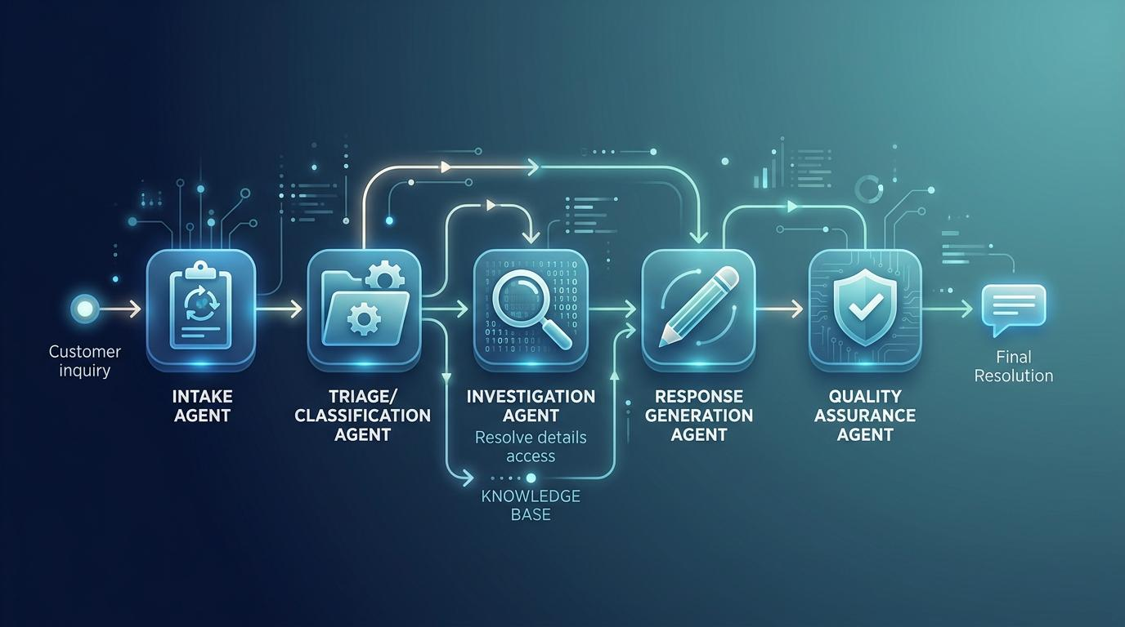
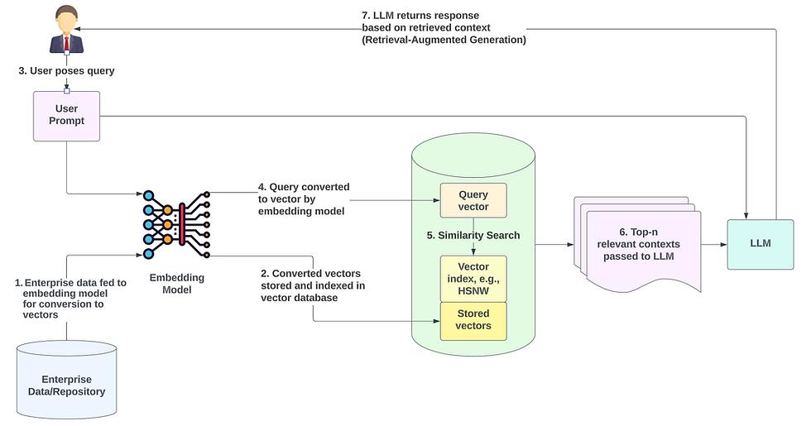
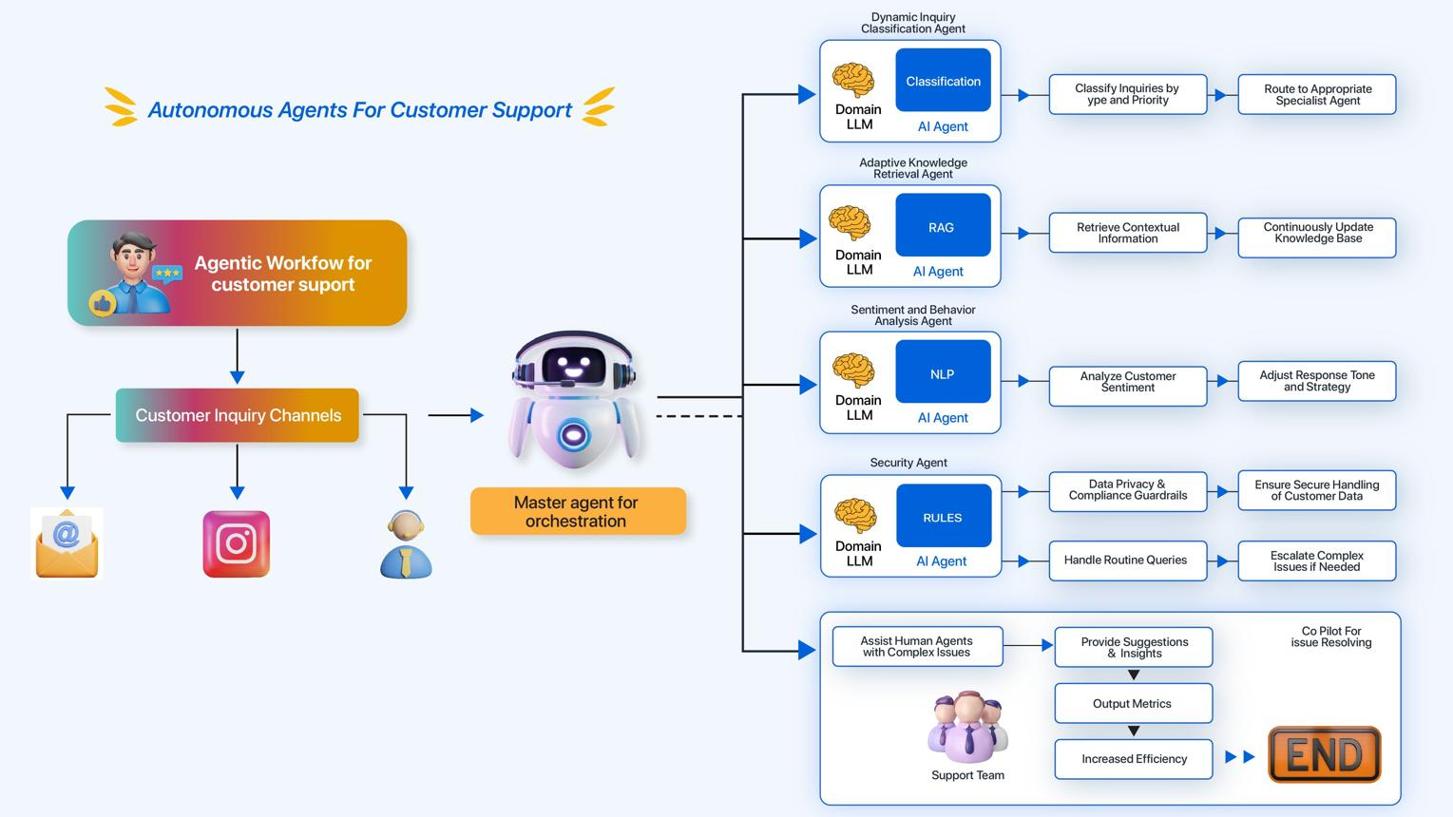
8
Remember the sequence:
Ticket → Classification → Retrieval → Response → Decision → Conditional Escalation → End
Human feedback is a separate step in the current implementation. It stores reviewed resolutions in CSV but does not automatically feed them back into the live workflow.

4. Five technical points to remember

A. What does the Classification Agent predict?
It predicts three things:
- Category: What type of problem is being reported?
- Priority: How urgent is the ticket?
- Sentiment: What sentiment does the ticket express?
For example, a customer reporting a damaged product might be classified as Product Issue, with a predicted priority and sentiment.

B. What is FAISS doing?
FAISS searches vectors efficiently.
The system converts text into numerical embeddings, then searches for documents whose vectors are similar to the query vector.
Important: Similarity does not guarantee relevance. Your email-update test demonstrated why retrieved resolutions must be checked.

C. What does the Response Agent do?
It prepares a suggested response using the retrieved historical resolution or an applicable fallback.
Your targeted email-update correction is an example of adding a safeguard when a known type of question receives an inappropriate historical resolution.

D. What does LangGraph do?
LangGraph connects the agent functions into a defined workflow.
In my implementation, it also supports conditional routing after the Decision Agent, allowing the workflow to invoke the Escalation Agent when required.

E. Does the system learn automatically from feedback?
Not yet.
The feedback form stores reviewed resolutions and optional corrected categories in CSV. Those records can support future improvements, but the current implementation does not automatically retrain the models or update the FAISS index.
Being honest about this limitation will strengthen your explanation rather than weaken it.

5. Viva practice — Question 2
Now let's test your technical understanding.
Question: What is the difference between the Classification Agent and the Retrieval Agent in your project? Why do you need both?
Answer in your own words, just as you did with the first question.

🎯 GUVI Project 6 — Viva Preparation Master Guide

1. Project architecture and business understanding
These are the questions an evaluator may ask first.

Q1. What problem does your project solve?
Suggested answer:
E-commerce platforms receive large volumes of customer support tickets related to payments, refunds, deliveries, and product issues. Manual handling can be slow and inconsistent.
My project automates the initial processing of these tickets by predicting their category, priority, and sentiment, retrieving potentially relevant historical resolutions, generating a suggested response, and determining whether escalation is required.

Q2. Why did you choose a multi-agent architecture instead of one large function?
A multi-agent architecture separates responsibilities into manageable components.
For example:
- The Classification Agent predicts ticket attributes.
- The Retrieval Agent searches historical information.
- The Response Agent prepares a reply.
- The Decision and Escalation Agents control the workflow.
This modular design makes individual components easier to understand, test, maintain, and improve.
Important: In your implementation, these agents are Python functions orchestrated by LangGraph. They are not necessarily independent AI models or autonomous LLMs.

Q3. Explain your end-to-end workflow.
Remember this sequence:
Ticket → Classification → Retrieval → Response → Decision → Conditional Escalation → End
The Streamlit application displays the results, and the human reviewer can separately record feedback in CSV.

Q4. Why did you use LangGraph?
LangGraph lets us represent the processing steps as nodes and their transitions as edges.
In my project, it connects the agents in a defined sequence and supports conditional routing after the Decision Agent.

Q5. What happens if the system produces an incorrect answer?
The current implementation can produce an incorrect or irrelevant suggested resolution. A human should review the answer before sending it to a customer.
The feedback form allows a reviewer to record a resolution and optional corrected category for future analysis.
The current feedback mechanism does not automatically retrain the models.

2. Classification and Machine Learning
Your project uses Scikit-learn models and saved TF-IDF vectorizers.

Q6. What is the difference between classification and retrieval?
This is particularly important because both are involved in your workflow.
Classification Agent | Retrieval Agent
Predicts labels for the incoming ticket | Searches for relevant historical documents
Uses trained classification models | Uses embeddings and FAISS similarity search
Predicts category, priority, and sentiment | Returns potentially relevant historical information
Answers: "What type of ticket is this?" | Answers: "Which existing documents might help?"
Why do you need both?
Classification helps the system understand and route the ticket. Retrieval provides historical information that may help prepare the response.

Q7. What is TF-IDF?
TF-IDF stands for Term Frequency–Inverse Document Frequency.
It converts text into numerical features based on how frequently words appear in a document and how informative those words are across a collection of documents.
A word that appears frequently in one document but less frequently across the entire collection may receive a higher weight.
Your saved TF-IDF vectorizers transform ticket text into features that the classification models can process.

Q8. Why did you use Scikit-learn?
Scikit-learn provides established implementations of text vectorization, classification algorithms, train/test splitting, and evaluation metrics.
It is suitable for building and evaluating traditional machine-learning models without requiring a large deep-learning infrastructure.

Q9. What is the difference between training and testing data?
- Training data is used to fit a model.
- Testing data evaluates the fitted model on data held out from training.
Your notebook used an 80/20 split, with 8,000 training rows and 2,000 testing rows.
However, your dataset contains repeated ticket texts, and some text appears in both sets. That overlap can make evaluation results overly optimistic.
For your viva, explain that a stronger evaluation would group identical or near-identical tickets before splitting the data.

Q10. What are accuracy, precision, recall, and F1-score?
Metric | Meaning
Accuracy | Fraction of all predictions that are correct
Precision | Fraction of predicted positives that are actually positive
Recall | Fraction of actual positives that are correctly identified
F1-score | Harmonic mean of precision and recall
For a customer support system, recall may be particularly important for a class representing urgent or negative tickets because missing those cases can be costly.
However, the best metric depends on the business objective and the consequences of false positives and false negatives.

Q11. What is a confusion matrix?
A confusion matrix compares actual labels with predicted labels.
It helps identify which classes the model predicts correctly and which classes it confuses.
For example, a ticket about a duplicate payment might be classified as a refund issue instead of a payment issue. The confusion matrix can help reveal this pattern across a labelled test set.

Q12. Why can a model have high accuracy but still perform poorly?
Accuracy can hide weak performance on minority classes.
For example, if most tickets belong to one category, a model can achieve high overall accuracy while frequently misclassifying less common categories.
That is why we should also examine per-class precision, recall, F1-score, and the confusion matrix.

3. Embeddings, FAISS, and RAG
This is one of the most important technical sections of your project.
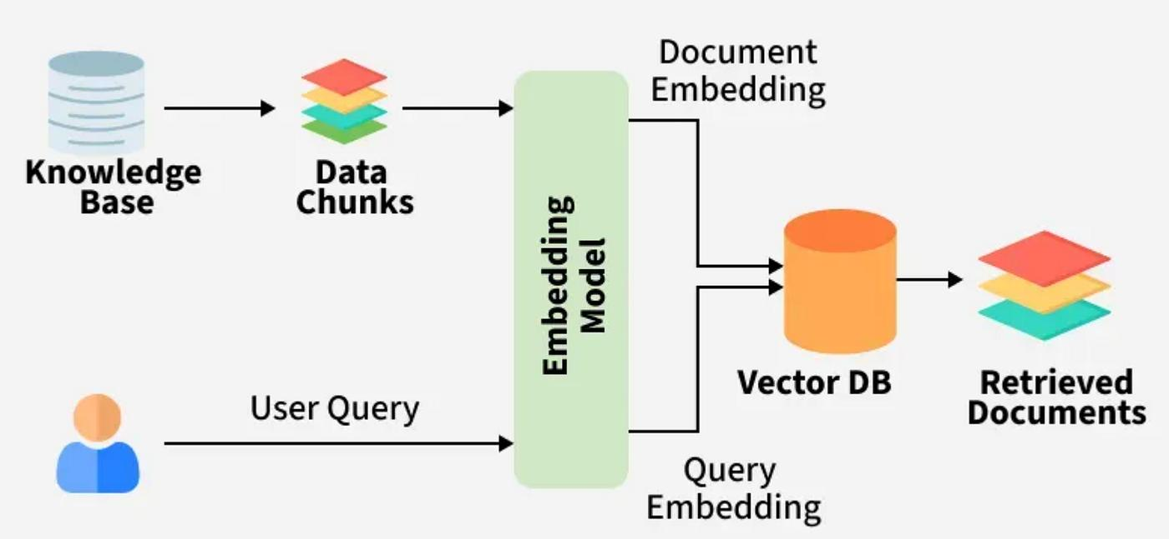
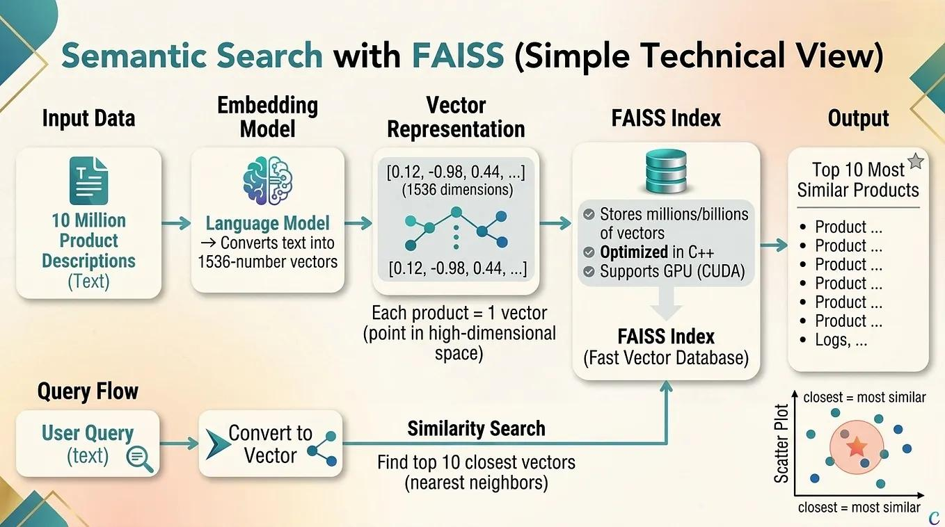
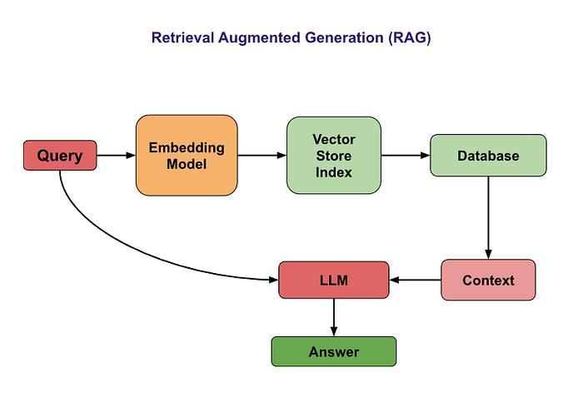
8

Q13. What is an embedding?
An embedding is a numerical vector representing information such as a sentence or document.
A sentence-embedding model maps text into a vector space where semantically related texts may have similar representations.
For example, these questions use different words but express similar intentions:
- "My parcel hasn't arrived."
- "Where is my delayed delivery?"
Their embeddings may be close in vector space.

Q14. What is FAISS?
FAISS is a library for efficient similarity search over dense vectors.
Your project uses it to search the stored embeddings of historical documents and retrieve candidate matches for an incoming ticket.

Q15. What is RAG?
RAG stands for Retrieval-Augmented Generation.
It combines retrieval of relevant information with response generation.
In your project:
- The incoming ticket is processed.
- The Retrieval Agent searches the vector index.
- Candidate documents are returned.
- The Response Agent uses a retrieved resolution or fallback logic to prepare a response.
Technical distinction: Your current response agent primarily extracts a historical resolution from a retrieved document. It is not a general-purpose LLM generating every response from scratch.

Q16. What is the difference between FAISS and an embedding model?
The embedding model converts text into numerical vectors.
FAISS indexes and searches those vectors.
In simple terms:
Embedding model = represents the text.
FAISS = finds similar vectors.
They perform different jobs and work together in the retrieval pipeline.

Q17. What is top-K retrieval?
Top-K retrieval returns the K highest-ranked candidate documents according to the search method.
For example, if K equals 5, the retriever returns up to five candidate documents.
However, the most similar document is not automatically the correct answer. Retrieval relevance must be evaluated separately.

Q18. Why did you use category-specific indexes as well as a global index?
Your hybrid retrieval design combines global retrieval with category-aware retrieval.
- Global retrieval searches across the broader document collection.
- Category-specific retrieval searches within documents associated with a particular category.
- Hybrid retrieval combines the results to improve candidate selection.
This can improve relevance, although its effectiveness must be demonstrated through evaluation rather than assumed.

Q19. What is retrieval confidence?
Retrieval confidence is a score used by your application to represent the strength of a retrieval match.
Its exact meaning depends on how the score is calculated in your implementation.
Do not describe a score of 66% as a 66% probability that the retrieved resolution is correct unless you have explicitly calibrated and validated it that way.

Q20. What is hallucination, and how can RAG help reduce it?
A hallucination is an output that is incorrect or unsupported but presented as if it were true.
RAG can reduce this risk by supplying relevant supporting information to the response process.
However, RAG does not eliminate hallucinations or irrelevant answers. If the retriever returns an inappropriate document, the response can still be wrong.
Your email-update test is a good example of why retrieval relevance matters.

4. LangGraph and multi-agent orchestration

Q21. What is a node in LangGraph?
A node is a function or processing step in the graph.
Your graph defines nodes for:
- Classification
- Retrieval
- Response generation
- Decision-making
- Escalation
Each node receives workflow state and can return updates to that state.

Q22. What is an edge?
An edge defines the transition between graph nodes.
For example, your graph connects the Classification Agent to the Retrieval Agent.

Q23. What is conditional routing?
Conditional routing determines which path the graph follows based on a condition.
In your project, the Decision Agent checks whether escalation is required.
- If escalation is required, the graph invokes the Escalation Agent.
- Otherwise, the graph ends without invoking that agent.

Q24. What is the role of SupportState?
SupportState defines the information exchanged and maintained throughout the workflow.
It allows agents to access relevant values such as ticket text, predicted category, priority, sentiment, retrieved documents, response, and escalation information.

Q25. Are your agents independent AI models?
No. They are modular Python functions connected by LangGraph.
Some functions use trained machine-learning models, while others implement retrieval, decision logic, response preparation, or escalation.
This distinction matters because multi-agent orchestration does not require every agent to be a separate LLM.

5. Response generation, escalation, and human feedback

Q26. How does your Response Agent generate a response?
It extracts a historical resolution from the top retrieved document when available and incorporates it into a customer-facing response.
If no usable resolution is found, it uses fallback wording.
Your email-update safeguard provides targeted instructions for that particular request type.

Q27. How does the Escalation Agent decide whether to escalate?
Your workflow uses priority and sentiment conditions to determine whether escalation is required.
High priority or negative sentiment can trigger escalation.
The exact behavior should be explained from your escalation.py and decision.py implementations if the examiner asks for the complete decision logic.

Q28. Why is human review important?
Human review can identify incorrect classifications, irrelevant resolutions, and inappropriate responses.
It is particularly important when the output affects customer payments, refunds, account access, or other sensitive business operations.

Q29. Does your Learning Agent automatically improve the model?
Not in the current implementation.
Your feedback component records reviewed resolutions and optional corrected categories in CSV.
Those records could be used later to update the dataset, evaluate response quality, retrain models, or refresh the retrieval index. Those updates currently require additional implementation.

Q30. Why did you use CSV rather than PostgreSQL?
CSV is simple to implement and sufficient for demonstrating persistent feedback storage in a small project.
A database such as PostgreSQL would be more appropriate for concurrent users, structured queries, larger datasets, access control, and more advanced reporting.
The GUVI instructions allow CSV storage as a basic implementation option.

6. Streamlit, deployment, and project files

Q31. Why did you use Streamlit?
Streamlit provides a straightforward way to create an interactive Python application without building a separate frontend.
Your interface allows users to submit tickets and inspect classifications, confidence scores, suggested responses, escalation decisions, retrieved documents, and feedback.

Q32. Why did you save the models and vector indexes?
Saving these artifacts avoids repeating model training and vector-index construction whenever the application starts.
Your runtime loads the stored .joblib models, embedding model, FAISS indexes, and retrieval metadata.

Q33. Does the project require FastAPI?
Not necessarily. The supplied GUVI instructions permit modular Python functions as an alternative to a FastAPI backend.
Your current implementation uses Streamlit with a Python/LangGraph workflow, so adding FastAPI is not necessary just to demonstrate the existing system.

Q34. What are the main limitations of your project?
A strong answer would be:
The current system can misclassify ambiguous tickets or retrieve irrelevant historical resolutions. Confidence scores are not guarantees of correctness. The feedback mechanism stores human-reviewed resolutions but does not automatically retrain the models or update the vector index. The system is currently a working demonstration, and additional evaluation and safeguards would be required before production use.

Q35. What would you improve if given more time?
You could mention:
- Improve retrieval relevance and evaluate top-K results.
- Evaluate response quality with human ratings or suitable automated metrics.
- Reduce data leakage from repeated ticket texts.
- Use feedback to improve future model versions.
- Add more robust monitoring, persistent ticket records, and production safeguards.

7. Questions about your actual project results
These questions may be harder because the evaluator can ask you to defend your results.

Q36. How many tickets did you use for end-to-end testing?
You tested seven sample tickets covering issues such as delayed delivery, account email updates, duplicate payments, returns, damaged products, login problems, and website issues.
Be clear: these seven tests verified that the workflow executed. They do not establish the overall accuracy of the system.

Q37. What did your email-update test reveal?
It revealed that the system could classify a ticket correctly but still return an irrelevant historical resolution.
You then introduced a targeted safeguard for email-update requests and tested the corrected response.
This demonstrates an important principle: correct classification does not guarantee correct response generation.

Q38. Why might a duplicate-payment ticket be classified as a refund issue?
The model learns patterns from its training data. A ticket mentioning a charge, refund, or returning money may resemble examples labelled as Refund & Return.
The prediction depends on the learned feature patterns and the available training examples.
A stronger model would require reviewing the labelled examples, examining the confusion matrix, and evaluating the model on a test set with reduced duplicate-text leakage.

Q39. How would you evaluate retrieval quality?
One approach is to prepare test queries with human-identified relevant documents.
We could then measure:
- Precision@K: How many of the retrieved top-K documents are relevant?
- Recall@K: How many relevant documents appear among the top-K results?
- MRR: How highly the first relevant document is ranked.
- Human relevance ratings: Whether retrieved resolutions genuinely address the question.
Your current retrieval-confidence scores alone do not establish retrieval accuracy.

Q40. How would you evaluate response quality?
Human reviewers could rate whether each response is:
- Relevant to the ticket.
- Factually supported by the retrieved information.
- Complete and actionable.
- Appropriate in tone.
- Safe to send to the customer.
BLEU and ROUGE can be used in some response-evaluation settings, but they do not necessarily establish whether a customer support answer is correct or useful.

8. Five mistakes to avoid during your viva
1. Don't claim that the system is fully autonomous.
It has a working multi-agent workflow, but human review remains important.
2. Don't say that FAISS generates answers.
FAISS searches vectors. Your Response Agent prepares the suggested response.
3. Don't say that feedback automatically retrains the models.
It currently stores records in CSV.
4. Don't claim 100% accuracy based on seven functional tests.
Functional execution and predictive accuracy are different measurements.
5. Don't confuse similarity with correctness.
A highly similar historical document can still contain an inappropriate resolution.

9. My recommendation: practise a mock viva
Partner, you now have a strong question bank. You don't need to memorize all 40 answers at once.
I recommend practising in this order:
- Project architecture.
- Classification versus retrieval.
- TF-IDF and classification metrics.
- Embeddings, FAISS, and RAG.
- LangGraph and conditional routing.
- Escalation and human feedback.
- Results, limitations, and future improvements.
We can practise just like a real evaluator: I'll ask one question at a time, you answer in your own words, and I'll grade your answer and correct the technical gaps.
Let's begin with a slightly tougher question:

Mock Viva — Question 1
Your system correctly classifies a ticket as Account & Login, but the retrieved document contains an unrelated resolution.
Why does correct classification not guarantee a correct customer response, and which components of your architecture would you investigate to fix the problem?

1. What is LangChain?
LangChain is a framework for building applications powered by Large Language Models (LLMs).
Technically, it provides abstractions and integrations for connecting language models with prompts, document loaders, retrievers, tools, and output parsers.
Instead of manually writing all the code to connect these components, developers can use LangChain's building blocks.

